**SAMPLE MCAS High School Biology Reference Sheet**

**CHEMISTRY OF LIFE**

C –

H –

N –

O –

P –

S –

|  |  |  |  |
| --- | --- | --- | --- |
| **Molecule** | **Building Blocks** | **Structure** | **Function** |
| C |  |  |  |
| P |  |  |  |
| L |  |  |  |
| NA |  |  |  |

Enzymes –

**CELL BIOLOGY**

cyto – cell

|  |  |  |  |
| --- | --- | --- | --- |
|  |  |  |  |
| **Cell Structure** |  |  |  |
| **Type of Organisms** |  |  |  |
| **Similarities** |  |  | |

**CELL BIOLOGY (continued)**

6:

A   
E   
  
P   
F   
P   
A

auto – self

hetero – different

uni – one

multi – many   
di- two

C, W 🡪 G, O G, O 🡪 C, W

[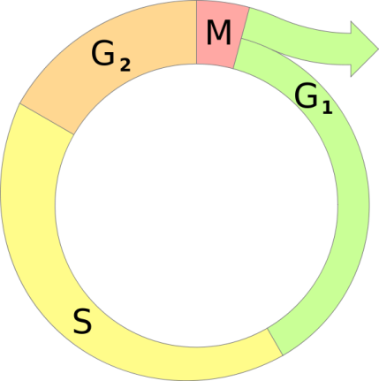](http://upload.wikimedia.org/wikipedia/commons/0/08/Cell_cycle_diagram.svg)

Mitosis Meiosis

|  |  |  |
| --- | --- | --- |
| # daughter cells |  |  |
| # chromosomes |  |  |
| type of cell |  |  |
| compared to parent cell |  |  |

**GENETICS**

homo – same

hetero – different

geno – genes

pheno – physical

poly – many

__NA – ATCG

__NA – AUCG

TL

TC

**EVOLUTION**

K  
P  
C  
O  
F  
G  
S

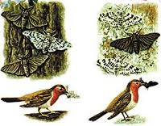

Evidence:

1-

2-

3-

4-

**ECOLOGY**

primary – 1

secondary – 2

tertiary – 3

M = (+, +)

C = (+, 0)

P = (+, -)

HOC

TC

SC

PC

P

* = flow of energy

**ANATOMY AND PHYSIOLOGY**

M, P, E, S, S, L, R M/N, P, T, B, B, A A=Away, V=Toward

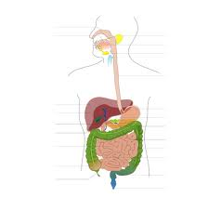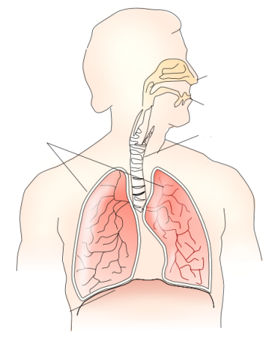

[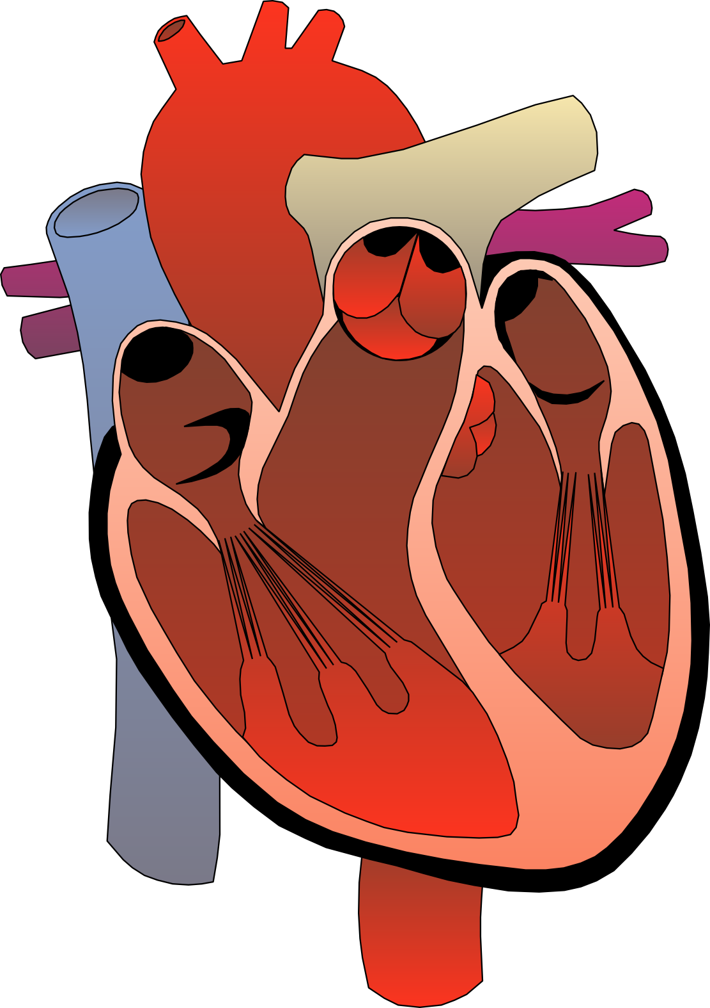](http://www.google.com/url?sa=i&rct=j&q=heart+diagram&source=images&cd=&cad=rja&docid=hdyyzJMV8JBVlM&tbnid=JbxFxSbH_je5iM:&ved=0CAUQjRw&url=http://clipartist.net/svg/heart-medical-diagram-1-scallywag-clipartist-net-art-svg/&ei=AI2CUdj6OsrE0QG3nYGIDw&bvm=bv.45921128,d.dmQ&psig=AFQjCNE5vdp4MPcOgOLihrmef6s7QlQ42g&ust=1367596665399019)

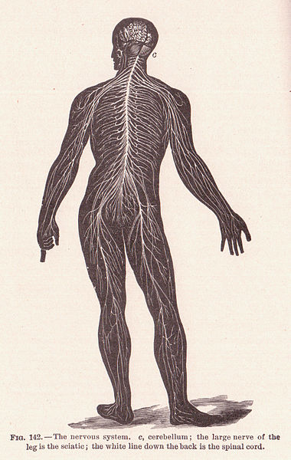

S=Toward, M=Away T=M+M, L=M+B

[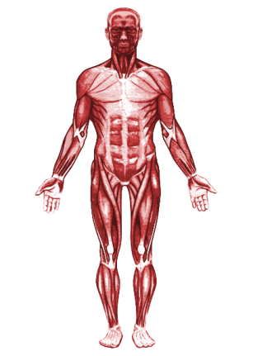](http://upload.wikimedia.org/wikipedia/commons/1/13/Muscular_system.svg)