Cell & Human Body Systems Test ANSER SHEET NAME: ___________________________________ Block: ___
Matching: Write the letter of the word that matches the definition. 1 point each

- Small intestine
- Alveoli
- Heart
- White blood cells
- Kidneys
- Brain
- Liver
- Bones

- Vacuoles
- Ribosomes
- Golgi apparatus
- Mitochondria
- Lysosome
- Nucleus
- Chloroplast
- Endoplasmic Reticulum

Open Response Questions: Pick 2 of the following 3 questions. If you choose to answer numbers 1 and 2, you cannot use the same body systems from number 1 to answer number 2. Answer on a SEPARATE piece of paper!

- When a person exercises, the rate of cellular respiration increases to supply the body with more energy in the form of ATP. Mitochondria require oxygen to carry out cellular respiration to make ATP from glucose. Describe how the circulatory and respiratory systems interact to transport a molecule of oxygen from the air to a mitochondrion. Be sure to discuss both systems IN DETAIL in your response. (10 points)

- Pick 2 body systems. Explain their functions and at least 2 organs from each system that help to carry out that function. Then, describe how those body systems work together to maintain homeostasis. (10 points)

- Pick 3 specialized human cells you learned about. List the body system they are found in, and explain their function and how their structures allow them to carry out that function. (10 points)

Multiple Choice: 2 points each

- What “food tube” carries food between the pharynx and the stomach?

- Where does the process of chemical digestion begin?

- Water is extracted from digested food in the body primarily by the

- The function of the excretory system is to control homeostasis and

- The main organs of the excretory system are the

- Which body system acts in a way similar to a transportation (ex. highway) system?

- Which of the following is NOT a part of circulatory system?

- Which of the following are the smallest of the blood vessels?

- Because there is more oxygen in an alveolus than in the blood around it, oxygen diffuses

- The process by which organ systems maintain a relatively stable internal environment is called

- Which system coordinates the body’s response to changes in its internal and external environment?

- What is the smallest structural and functional unit of the nervous system?

- Which of the following provides support for the body, attachment sites for muscles & protection for internal organs?

- Ligaments connect

- Which organ system is responsible for making and delivering sperm?

- Which of the following is an example of an organism maintaining homeostasis?

- Some cells, such as human nerve and muscle cells, contain many more mitochondria than do other cells. Why do some cells have more mitochondria than others?

- All of the following are found in the female reproductive system EXCEPT

- The two types of human gametes (reproductive cells) are

- Diffusion is

- Osmosis is

- If a cell with a 20% Na+ (sodium ion) concentration is surrounded by a solution with 15% Na+, in what direction will water move? (Assume that the solutions consist of only water and Na+).

- Which of the following is found in eukaryotes but not in prokaryotes?

- Which of the following is found in prokaryotes but not in eukaryotes?

- All of the following are examples of cell specialization EXCEPT
- The cell theory states all of the following EXCEPT

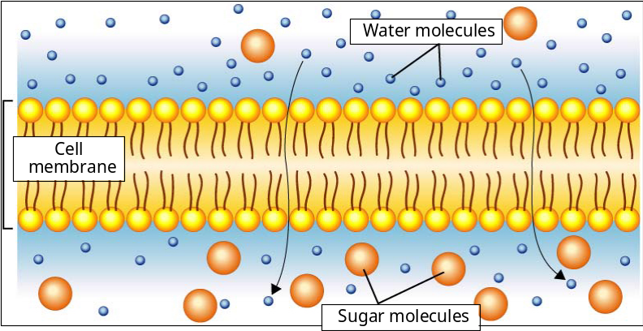
Outside of Cell
Inside of Cell

Figure 3- The cell membrane is impermeable to sugar molecule

Use Figure 3 to answer numbers 27 and 28.

- In Figure 3 above, the solution in the cell is ___________ compared to the solution outside of the cell.
- Which is increasing inside the cell?

